NEWSLETTER
WAYNE MENDENHALL
September, 2016
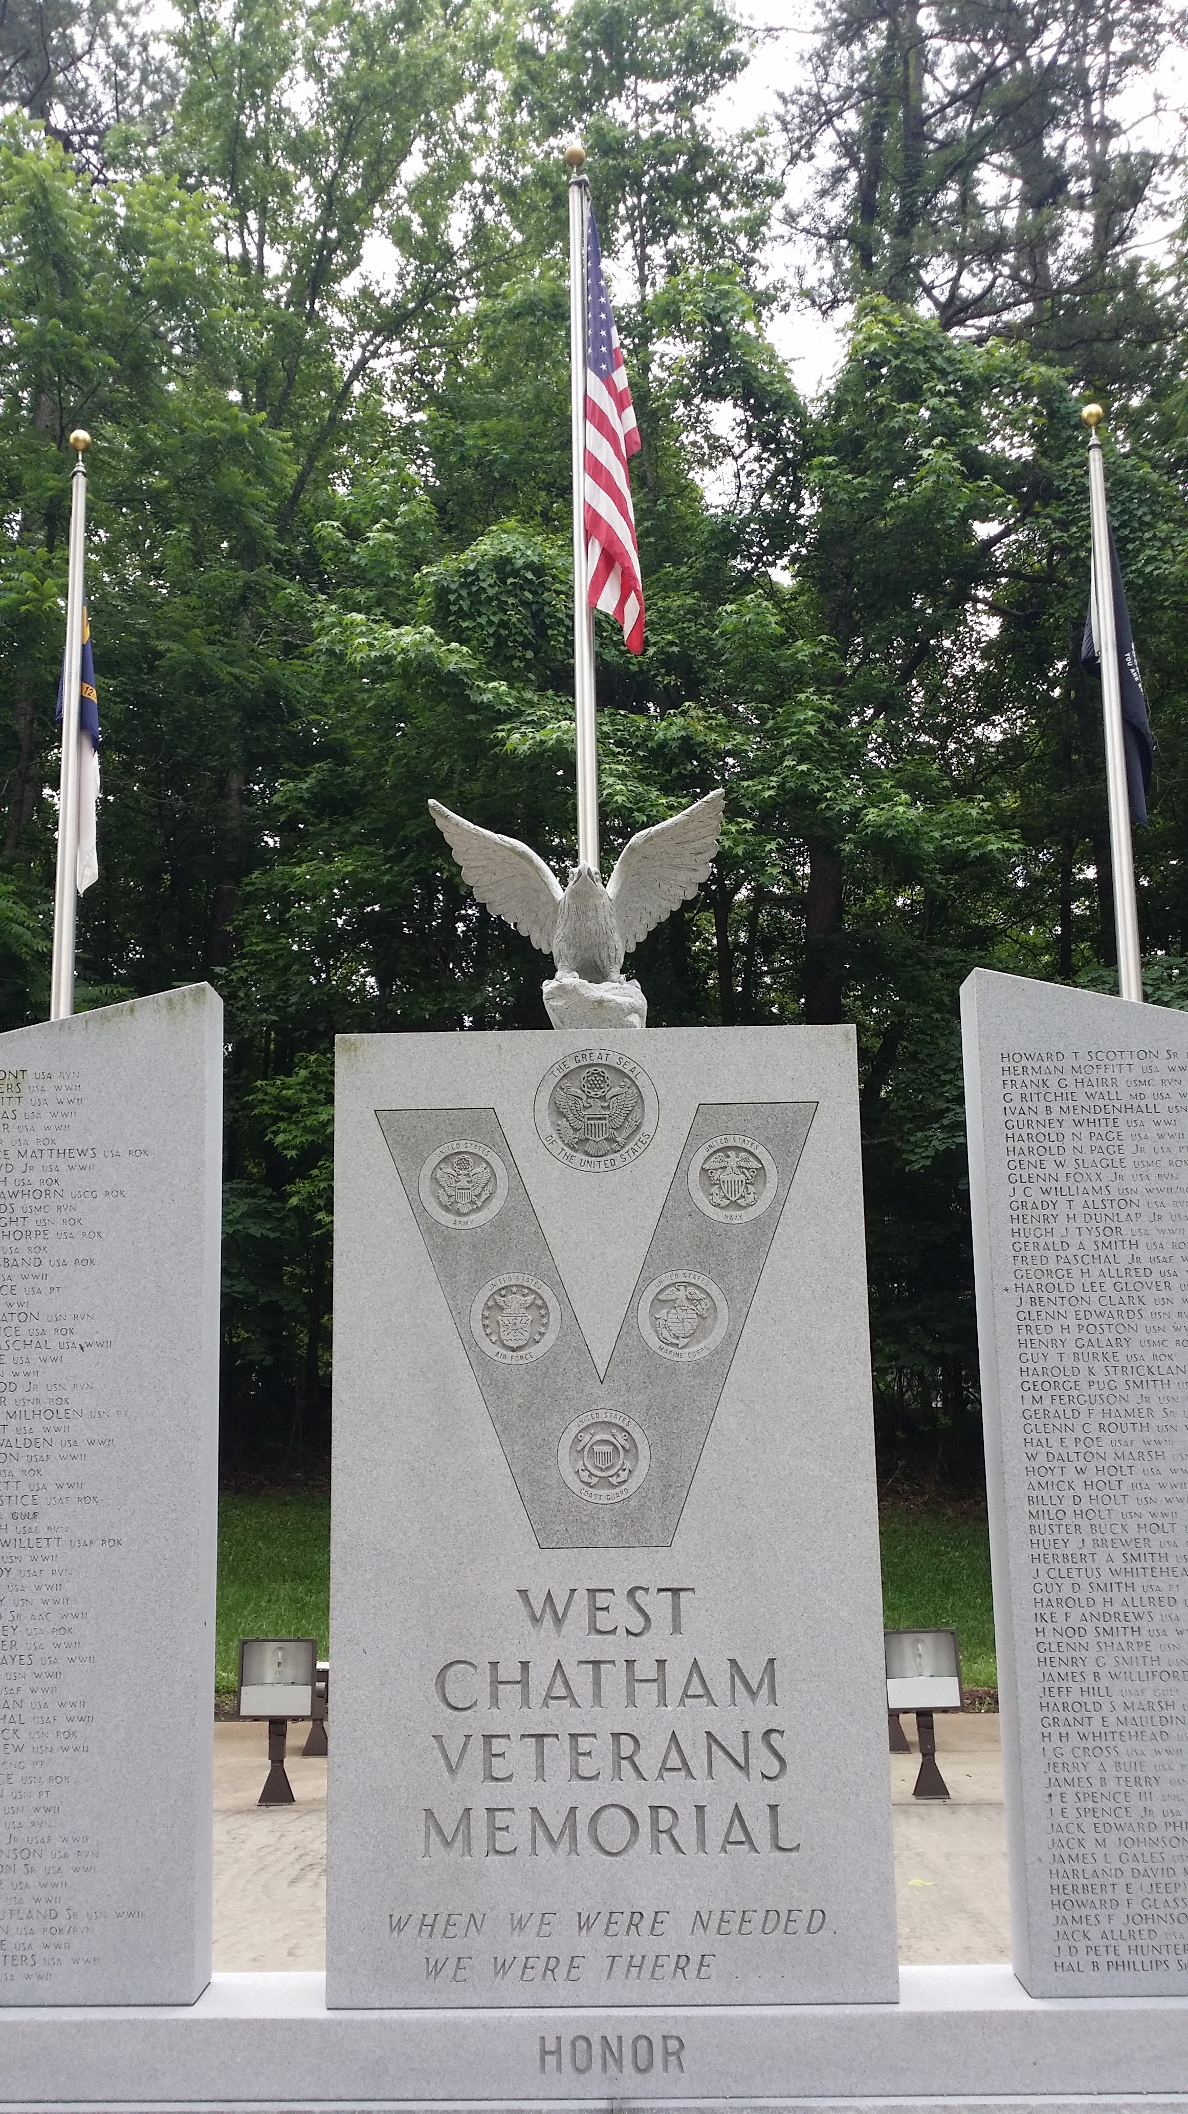

SILER CITY POST #0093
For God and Country
919-200-1809
Jeff Cathcart, Post Commander

Post meetings are held the 4th Tuesday of each month at 6:00 p.m.
at the Drydock Seafood Restaurant
408 N. 2nd Avenue, Siler City, NC 27344

COMMANDER’S MESSAGE

Greetings & salutations…At our next meeting on October 25th, please be sure to see me to verify your email address. We need to be able to communicate in between meetings in case of unexpected events, schedule changes, cancellations, etc. I would like to be able to send out a group email when changes occur; it’s simply not practical to make 30+ phone calls to our Post members to let folks know what’s going on, in between our regular meetings. If you don’t have an email account, perhaps you know someone who does, who would be willing to relay a message to you?

We have an extremely busy and exciting agenda planned for the year ahead. Please plan on attending all meetings, and participate, whenever and wherever possible. We need you! You are the American Legion…. Together, everyone achieves more, for our fellow veterans, and our community. Thank you for your continued service!

WHAT’S HAPPENING

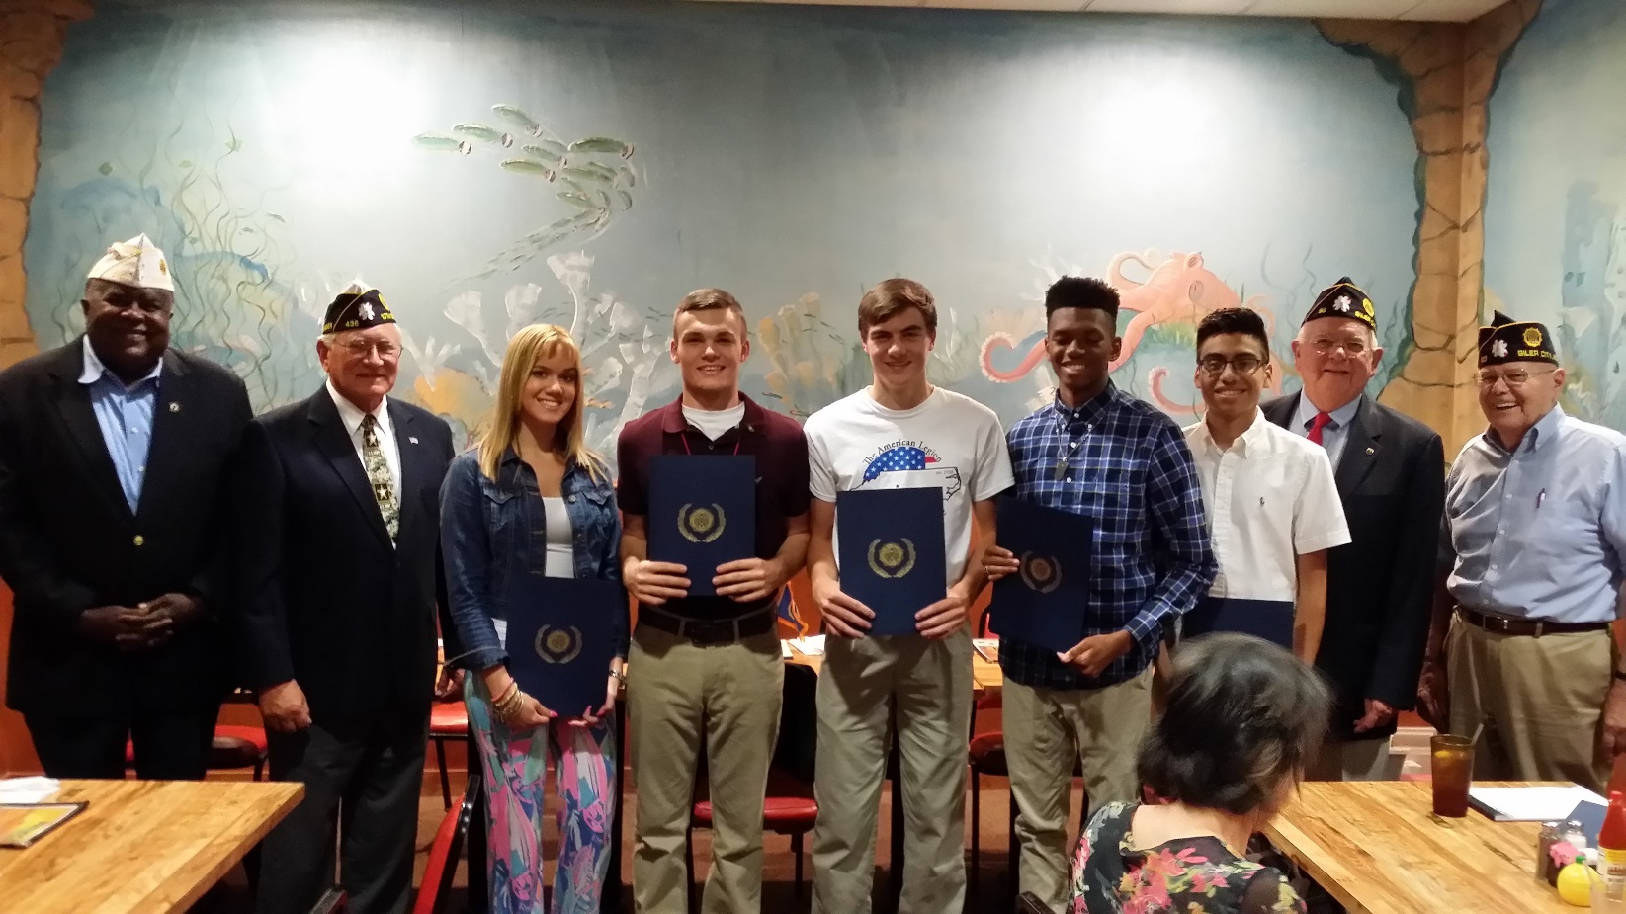
At our September meeting, Boys’ and Girls’ State delegates received a certificate of appreciation for program participation and a ‘good citizen’ certificate. Each student shared highlights from their experience and enjoyed a dinner with their parents, as guests of Post 93. Pictured above (from left to right) are: Division 3 Commander, Turner Totten, District 13 Commander, Ted Martin, Girls’ State delegates, Claire Brady, Abby Lewis (not pictured), Boys’ State delegates Tyler Haiges, Brenton Hart, Jaylan Paige and Andy Morales-Lagunes; Post 93 Youth Programs Committee Chairman, Bill Milholen and Post 93 Commander, Bill Elder.
Post 93 elections were held at the September meeting. All nominees were elected to the offices for which they were nominated. Elected officers for 2017 are as follows: Post Commander, Jeff Cathcart; Jeff will continue to serve as Post Adjutant, as well as Commander. Post Vice Commander, Zach Nichols, Post Finance Officer, Bill Elder; Bill will serve as Post Chaplain, as well as Finance Officer, and Post Service Officer, Bill Haiges.

We continue to collect pop-top tabs for Ronald McDonald House Charities. The aluminum tabs will be recycled and the money received from the recycling will be donated to Ronald McDonald House. Please start saving your tabs and bring them with you each time you attend a regular Post meeting.

CALENDAR OF EVENTS

OCT. 25 Post Meeting
NOV. 11 Veterans Day Parade / Awareness Walk
NOV. 22 Post Meeting / Mountaire Food Distribution
NOV. 22-28 National Family Week
NOV. 24 Thanksgiving
Our Annual Veterans Day Awareness Walk will take place on November 11th as part of the Siler City Veterans Day Parade. A short memorial service will be held at the Chatham Veterans Memorial Monument location, with refreshments after the parade, at the Bray Park picnic cabana (next to the Monument). Members are encouraged to wear their blue legion cap and bring a guest to walk in the parade and gather with us for food and fellowship after the memorial service.

November 22-28 is National Family Week. Make sure you spend valuable time with your loved ones.

If you haven’t yet heard, Mountaire Farms, Tender Young Chickens, has purchased the old Townsend Chicken processing facility and will be bringing 500+ jobs to Siler City within the next year or so. Mountaire is extremely committed to the communities in which they serve, and they’re getting involved right away in our town. On November 22nd, our Post will come alongside The Holy Trinity United Holy Church of Siler City to assist Mountaire with the distribution of 1000 food boxes to local churches, to help those in need in our area. Please mark your calendar for November 22nd and plan on helping if you can. This will be a blessed event. By the way, this is the same date as our November regular Post meeting. The food distribution will not interfere with our meeting. We will meet at Drydock at 6pm as usual. Time and place of the food distribution will be announced at the October 25th meeting.

We anticipate participating in both the Pittsboro and Siler City Christmas parades in December. Please bring your ideas to the October 25th meeting.

