NEWSLETTER
WAYNE MENDENHALL
September, 2016
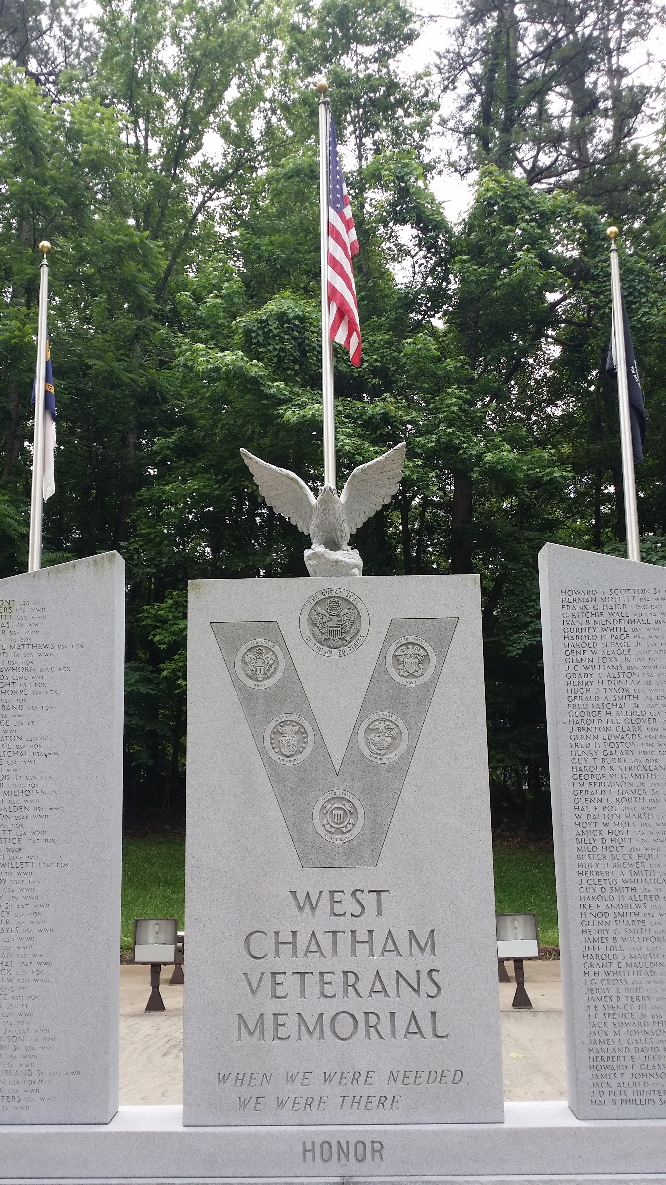
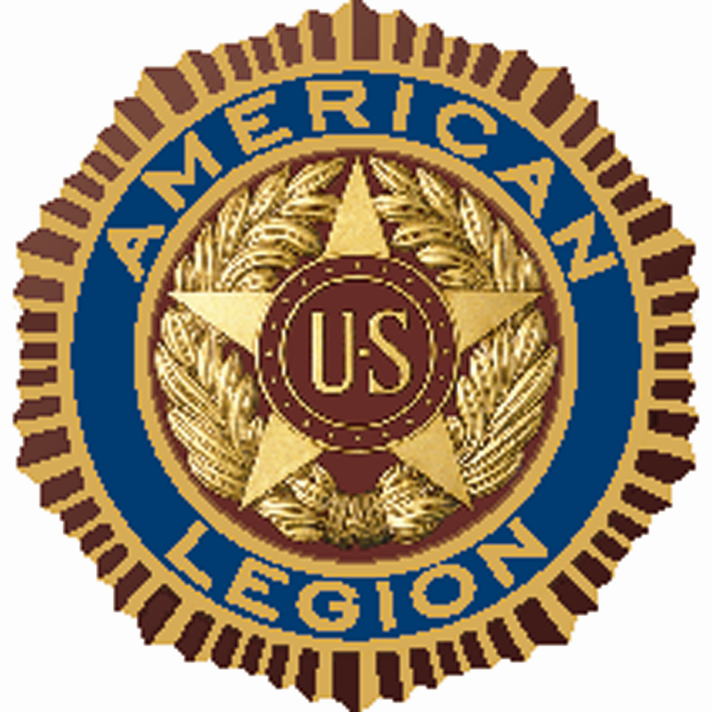

SILER CITY POST #0093
For God and Country
919-200-1809
Jeff Cathcart, Post Commander
jcathcart@freedomwon.org

Post meetings are held the 4th Tuesday of each month at 6:00 p.m.
at the Drydock Seafood Restaurant
408 N. 2nd Avenue, Siler City, NC 27344

COMMANDER’S MESSAGE

Greetings & salutations…At our next meeting on November 22nd, please be sure you see me to verify your email address. As I shared at our October meeting, this will be the last newsletter sent via U.S. Mail. All future routine communications will be done via email, or our website, once it’s up and running (hopefully in December). Of course, in the event of an emergency or a last minute change in plans, one of our post officers will notify all post members by phone.

Dinner at the November 22nd meeting will be paid for by our post. Please bring a guest and enjoy a great meal in honor of Veterans Day and your service to our country. Thank you!!

Our December meeting falls on December 27th; right between the Christmas and New Year holidays. Many of our members will be travelling and hosting guests during this time, therefore, we will cancel our December meeting. We will reconvene on Tuesday, January 24th at 6:00 p.m., at the Drydock Seafood Restaurant.

WHAT’S HAPPENING

We continue to collect pop-top tabs for Ronald McDonald House Charities. The aluminum tabs will be recycled and the money received from the recycling will be donated to Ronald McDonald House. Please start saving your tabs and bring them with you each time you attend a regular post meeting.

I’m mailing this newsletter a bit early this month because we have so much going on. Please see the following calendar of events below and plan on attending as many of these as possible.

CALENDAR OF EVENTS

NOV. 07 Town Council Proclamation
NOV. 11 Free Car Wash at Chatham Charter School
NOV. 12 Veterans Day Parade / Awareness Walk
NOV. 22 Post Meeting / Mountaire Food Distribution
NOV. 24 Thanksgiving (no post event)

On Monday, November 7th at 7:00 p.m., in the Siler City Town Council Chambers our Mayor and fellow Legionnaire, the Honorable John Grimes, will issue a proclamation honoring and celebrating our recent Boys’ & Girls’ State participants. Please plan to be there if you can.

On Veterans Day, Friday, November 11th, the Chatham Charter School Student Council will be honoring all veterans with a free car wash. Just drive your favorite ride to the school between 9:00 a.m. – 11:00 a.m. on Veterans Day and get clean! Let’s bless these great kids by showing up - and showing our appreciation, as they honor us!!

Our Annual Veterans Day Parade / Awareness Walk will take place on November 12th. A memorial service will be held at the Chatham Veterans Memorial Monument location, with refreshments after the parade, at the Bray Park picnic cabana (next to the Monument). Members are encouraged to wear their blue legion cap and bring a guest to walk (or ride) in the parade and gather with us for a snack and some fellowship after the memorial service. Some of our Legionnaires will be walking from the end of the parade route to the Monument in an effort to raise awareness about veterans in Siler City. They will be handing out flags and chatting with folks as they go. Please walk along with them if you can. If you’re not up to walking and would like to ride in the parade, please email Commander Cathcart at jcathcart@freedomwon.org or call him at 919-200-1809. We will pick you up at your home, see to it that you have a way to ride in the parade, and take you home afterwards. Please try to be there if you can.

If you haven’t yet heard, Mountaire Farms, Tender Young Chickens, has purchased the old Townsend Chicken processing facility and will be bringing 500+ jobs to Siler City within the next year or so. Mountaire is extremely committed to the communities in which they serve, and they’re getting involved right away in our town. On November 22nd, our Post will come alongside The Holy Trinity United Holy Church of Siler City to assist Mountaire with the distribution of 1000 food boxes to local churches, to help those in need in our area. Please mark your calendar for November 22nd and plan on helping if you can. This will be a blessed event. If you can volunteer your time, if only for an hour or two to help, please email Commander Cathcart at jcathcart@freedomwon.org or call him at 919-200-1809 to get on the volunteer list. By the way, this is the same date as our November regular post meeting. The food distribution will not interfere with our meeting. We will meet at Drydock at 6:00 p.m. as scheduled.

Although we won’t be having our December meeting we anticipate participating in both the Pittsboro and Siler City Christmas parades in December. Details will be discussed at the November 22nd meeting.

