NEWSLETTER
WAYNE MENDENHALL
September, 2016
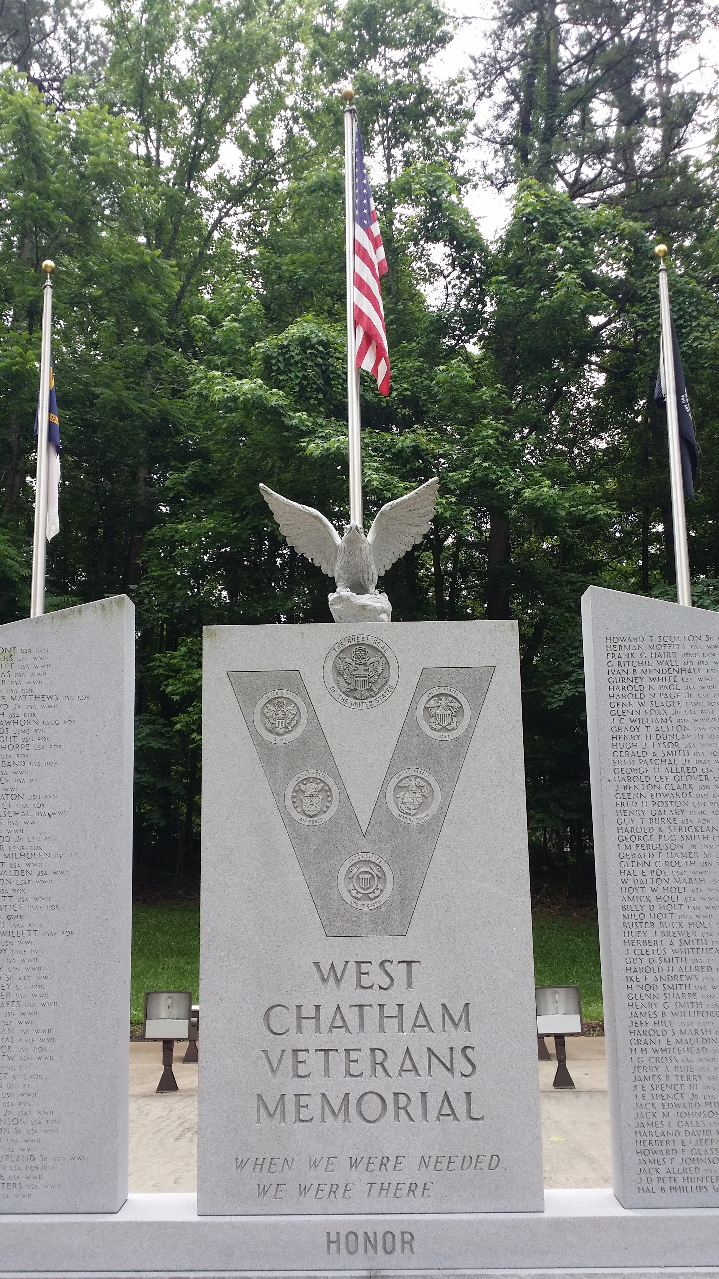
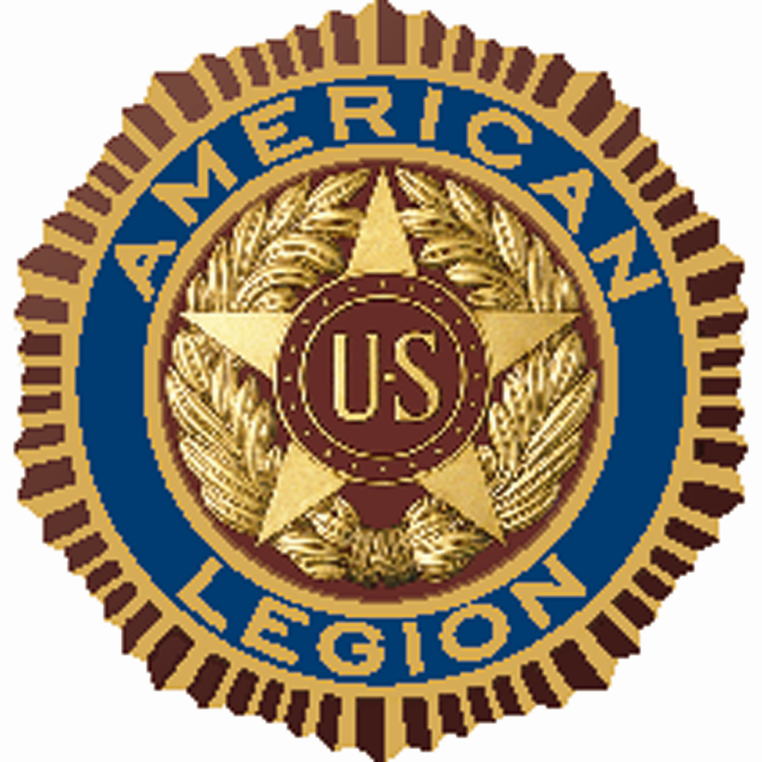

SILER CITY POST #0093
For God and Country
919-200-1809
Jeff Cathcart, Post Commander
jcathcart@freedomwon.org

Post meetings are held the 4th Tuesday of each month at 6:00 p.m.
at the Drydock Seafood Restaurant
408 N. 2nd Avenue, Siler City, NC 27344

COMMANDER’S MESSAGE:

Merry Christmas! As we celebrate this most wonderful time of the year I pray that each of you enjoys a safe and blessed holiday season. We have so much to be thankful for!! Glory to God…Amen.

As I shared at our November meeting, this will be the last newsletter sent to members via U.S. Mail. All future routine Post 93 communications will be done via email, and posted on our website, which will be rolled out in late-December, 2016. When you can’t attend meetings, please go to www.freedomwon.org to stay abreast of everything involving your Post 93. Of course, in the event of an emergency or a last-minute change in plans, one of our Post officers will notify all Post 93 members by phone.

Please remember that there will not be a regular Post 93 meeting in December, 2016. Many of our members will be traveling and hosting guests during the holiday season, therefore, we will postpone our December meeting so that we may enjoy and embrace our wonderful families who sacrifice so much throughout the year. We will reconvene our regular Post 93 meetings on Tuesday, January 24th, 2017, at 6:00 p.m., at the Drydock Seafood Restaurant.

WHAT’S HAPPENING:

We continue to collect pop-top tabs for Ronald McDonald House Charities. The aluminum tabs will be recycled and the money received from the recycling will be donated to Ronald McDonald House. Please bring your tabs with you each time you attend a regular Post 93 meeting.

Siler City’s Annual Veterans Day Parade / Awareness Walk & Memorial, was an amazing success on November 12th. Past Post 93 Commander, Bill Elder, and Past Adjutant, Bill Milholen, rode in Bill Milholen’s 1957 T-Bird Convertible, while Post 93 Commander, Jeff Cathcart, led the way on foot alongside fellow Legionnaires and other local veterans, handing out souvenir flags to parade goers along the way, and followed with the first annual Veterans Awareness Walk. A memorial service was held at the West Chatham Veterans Memorial location immediately following the parade, with refreshments provided by your Post 93. Legionnaires and fellow patriots were blessed by spiritual music and prayers by Pastor Mark Richardson and the Journey Church, remarks of reflection by Siler City Mayor and fellow Legionnaire, the Honorable John Grimes, and words of encouragement and remembrance by Post 93 Vice-Commander, Bill Haiges. Be sure to say “thank you” to the folks at the Siler City Merchant’s Association when you see them, specifically, Zoann Adams (wife of fellow Legionnaire, Sam Adams) and DeeDee Brown for starting this annual event four years ago, and for sticking with it to make it a success. Remember, our veterans are not honored because of Veterans Day - They are honored because great Americans like Zoann and DeeDee choose to honor them on Veterans Day, and every day! So, how do we say “thank you” to them for honoring us? How about if we support their businesses downtown? How about visiting the Holiday Market that’s going on during the entire month of December, at the PAF Gallery on Chatham Avenue (in the Incubator next to the Courtyard Café), from 10:00 a.m. – 4:00 p.m.

Past Post 93 Commander, Mike Bullis, is leading the charge for our Color Guard program. Mike has been evaluating uniforms and equipment and should be ready to start putting the program together by early-spring of 2017. If you’re interested in joining your Siler City, Post 93, Color Guard, please email Vice-Commander, Bill Haiges, at bhaiges@freedomwon.org for more information.
On November 22nd, your Post 93 came alongside Mountaire Farms, Tender Young Chickens, in feeding “Thanksgiving for 1000’s”. Post 93 Legionnaires assisted the Mountaire team at the old Townsend Chicken processing facility on I-64, the site of the new Mountaire processing facility, in showing the love For God and Country, by thoughtfully giving.
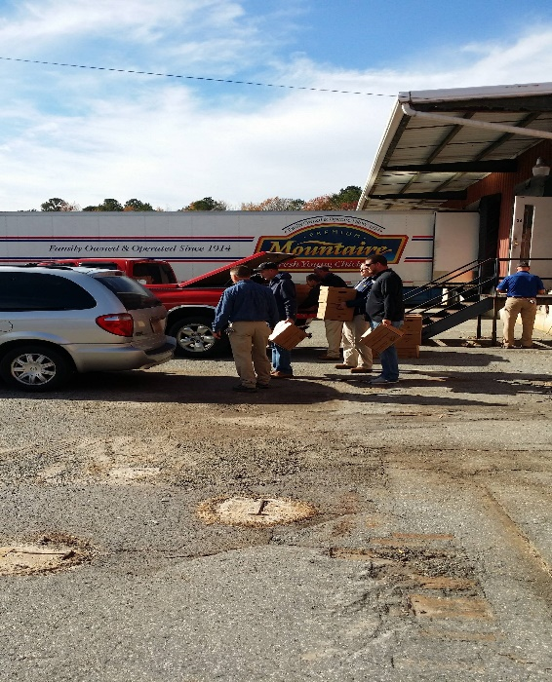
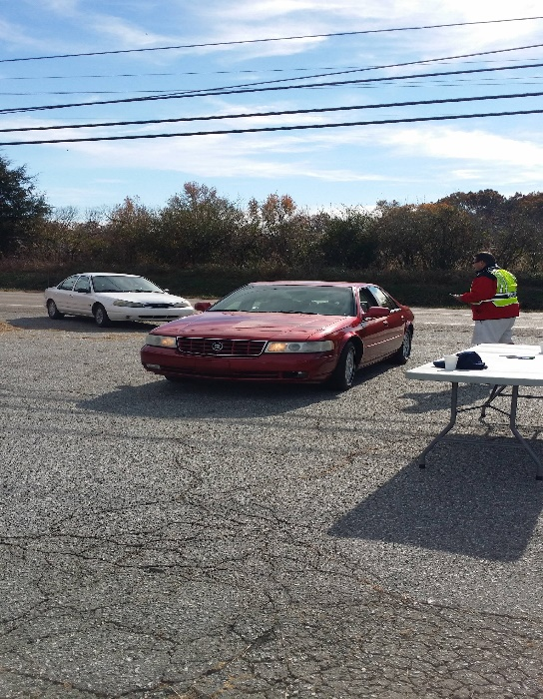

Left: Your Post 93 Vice-Commander, Bill Haiges, greets and directs local churches as they arrive to receive food boxes.

Right: Mountaire employees load
Food boxes into vehicles.

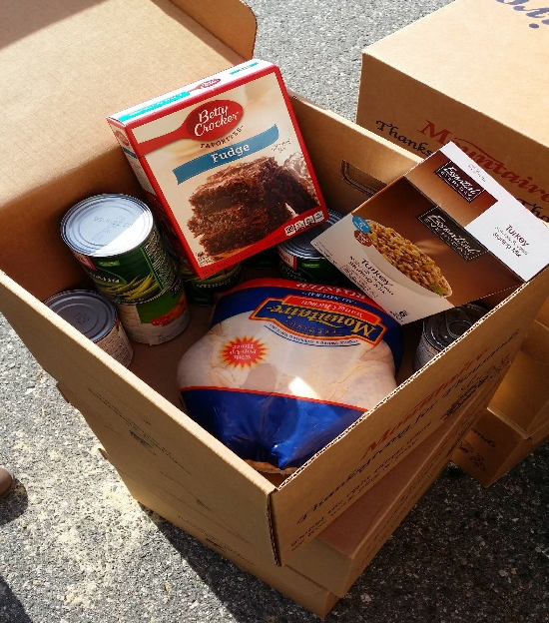
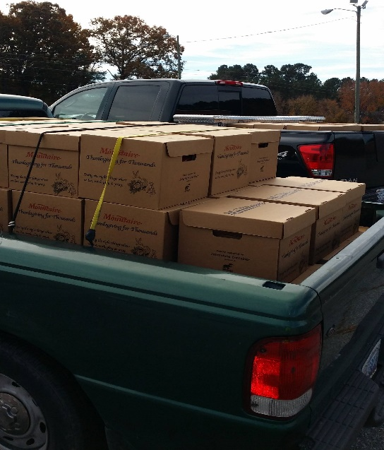
Left: A truck filled with boxes of meals for Thanksgiving is set to deliver the blessing to local churches.

Right: Each food box contained enough food to feed a family of five a complete Thanksgiving dinner including: A nine-pound roaster chicken, stuffing, sweet potatoes, cranberry sauce, green beans, corn and a cake mix.

We are now proud members of the Siler City Merchant’s Association, and soon to be with the Siler City Chamber of Commerce. One of your Post 93 officers attends every meeting, as well as, the meetings of the Siler City Development Organization (SCDO). Your Post 93 also just made our annual $1,000.00 donation to the Boys & Girls Club, and will soon begin our search for the next iteration of Tarheel Boys’ & Girls’ State delegates. As you can see, we have lots going on – Don’t miss out! Please email Commander Cathcart today at jcathcart@freedomwon.org or call him at 919-200-1809 to get involved….I promise, you WILL be blessed!!
TAPS

TRANSFERRED TO POST EVERLASTING

James R. Creason
Vietnam Veteran
Was called home on Wednesday, November 30th

