American Legion Post 93

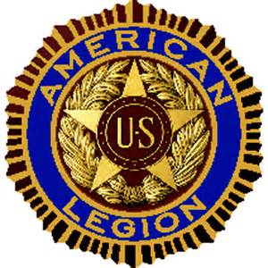
Minutes | September 27, 2016 | 6pm- 8pm | Drydock seafood Restaurant

Meeting called by | Commander Bill Elder
Type of meeting | Regular (1st of new year, after summer break)
Facilitator | Adjutant Jeff Cathcart
call to order | 6PM Meeting was called to order in accordance with the Manual of Ceremonies
Roll Call | Roll call of members was not accomplished. Division III Commander, Turner Totten, and District 13 Commander, Ted Martin, were in attendance
Approval of minutes from last meeting | Minutes were not read…There were no minutes from the previous meeting.

Agenda topics

2hours

old business | Commander Elder introduced the guests. Certificates were awarded to the NC Boys’ & Girls” State attendees; Andy Morales-Lagunes, Brenton Hart, Jaylan Paige, Tyler Haiges, Abby Lewis (not present), Claire Brady.
Committee reports: Finance – Veterans Affairs and Rehabilitation – National Defense – Americanism – Youth & Children
No committee reports were read…There were no committees formed at the time of this meeting. Committees will be formed at the October 2016 meeting.
new business | Elections of Commander, Vice Commander, Chaplain, Finance Officer, Service Officer
Elections were conducted. Bill Milholen nominated Jeff Cathcart for election as Commander and to continue on as Adjutant. All members present were in favor, none opposed. Bill Milholen nominated Zach Nichols for election as Vice Commander. All members present were in favor, none opposed. Bill Milholen nominated Bill Elder for election as Chaplain. All members present were in favor, none opposed. Jeff Cathcart nominated Bill Elder for election as Finance Officer. All members present were in favor, none opposed. Jeff Cathcart nominated Bill Haiges for election as Service Officer. All members present were in favor, none opposed. All newly elected officers accepted their respective nominations and subsequent elections.
There was no new business conducted. Adjutant Cathcart made several announcements of pending work to be done, and that all items would be addressed for action at the October 2016 meeting.
Action items |  | Person responsible | Deadline

[Time Allotted] | [Topic] | [Presenter]

Discussion

Conclusions
Action items |  | Person responsible | Deadline

[Time Allotted] | [Topic] | [Presenter]

Discussion

Conclusions
Action items |  | Person responsible | Deadline

[Time Allotted] | [Topic] | [Presenter]

Discussion

Conclusions
Action items |  | Person responsible | Deadline

[Time Allotted] | [Topic] | [Presenter]

Discussion

Conclusions
Action items |  | Person responsible | Deadline

Adjournment | Meeting closed by Commander Bill Elder in accordance with the Manual of Ceremonies.

Special notes

